THE GENT

October 2012 | No. 138

Tales from the corridor of uncertainty

Shocked Salix peruse the book

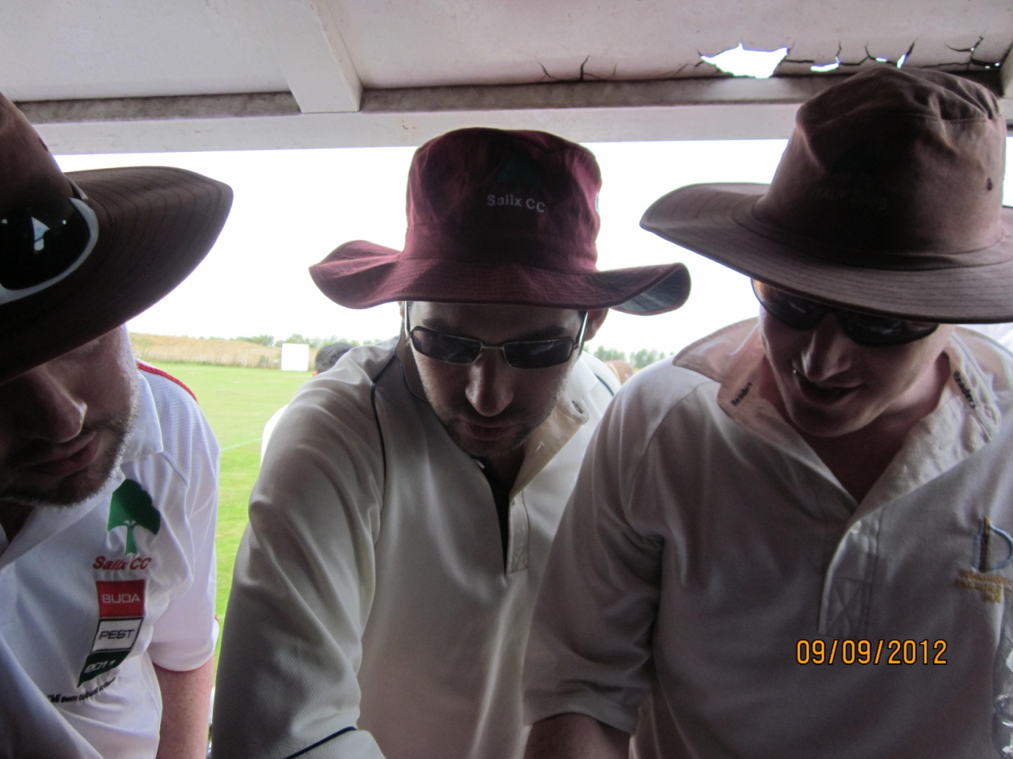

“Er, shouldn’t that be 52 for 9?”

Captaincy capers  Richard Gilkes returns with 93  George Wright smashes 126 against Clapham In  Sanjay Patel and Raj Pentakota set record stand  A sad day as Gents cancel 12 Angry Men  Around the circuit  Mendis equals Hill’s record  Peter Pan and cricket | A ton for you next year, bro’

Match reports:
Salix (won by 148 runs)
Clapham In (won by 93 runs)
Salix (won by 68 runs)
Hale (lost by 63 runs)

Contact this magazine via email andrewburman_840@hotmail.com or mobile 07802-788424

Read about the Gents on www.gowlcc.org.uk

Captaincy capers

Since Gent 137 we have seen brilliant innings by Messrs. Gilkes, G Wright and S Patel and a savage attack on the Gents and Clapham In by flying ants. The 12 Angry Men game was cancelled because the Gents could not raise a team. England’s Test Captain emulated Hemin Patel and resigned while the Tory party are said to be interested in both as prospective Parliamentary candidates. Gents and Hale were denied by Tropical Storm Nadine but regrouped a week later when Hale administered a cuffing.

The Gents have had six de jure captains in 2012, i.e. the chaps with the asterisk in the scorecard who toss the coin and decide a batting order, sometimes as far down as No.6. De facto captains may be up to 11 in number. Newcombe has captained nine times, Hemin Patel thrice, Sachin Desai and Sciberras twice and Sanjay Patel and Toft once each. There is a concept in chess known as Zugzwang (German for “compulsion to move”) where one player is put at a disadvantage because he has to make a move when he would prefer to pass and make none. The fact that the player must make a move means that his position will be significantly weaker than the hypothetical one in which it was his opponent’s turn to move.

That is precisely where the Gents are with the matter of the captaincy. The do nothing policy in which Vice-Captain Newcombe, or his nominated deputy, led until the end of the season has exceeded expectations. The leaders have relished the challenge. More importantly they have enjoyed it. Whereas constitutionally the matter needs to be decided, the feeling is that the outcome may not be preferable to the relaxed enjoyment the above gentlemen have brought to this year’s games. Somebody is sure to be disappointed.

We must at this point pay tribute to Greg Newcombe’s firm but open leadership. He has taken counsel but made his decisions and stood by them. He has mentored the Wrights, acted with respect to players old and new and has not been afraid to muck in with the unglamorous organisational work. Out of chaos has come some exceptional cricket this season and a good share of the credit for that is his.

A perfect comeback

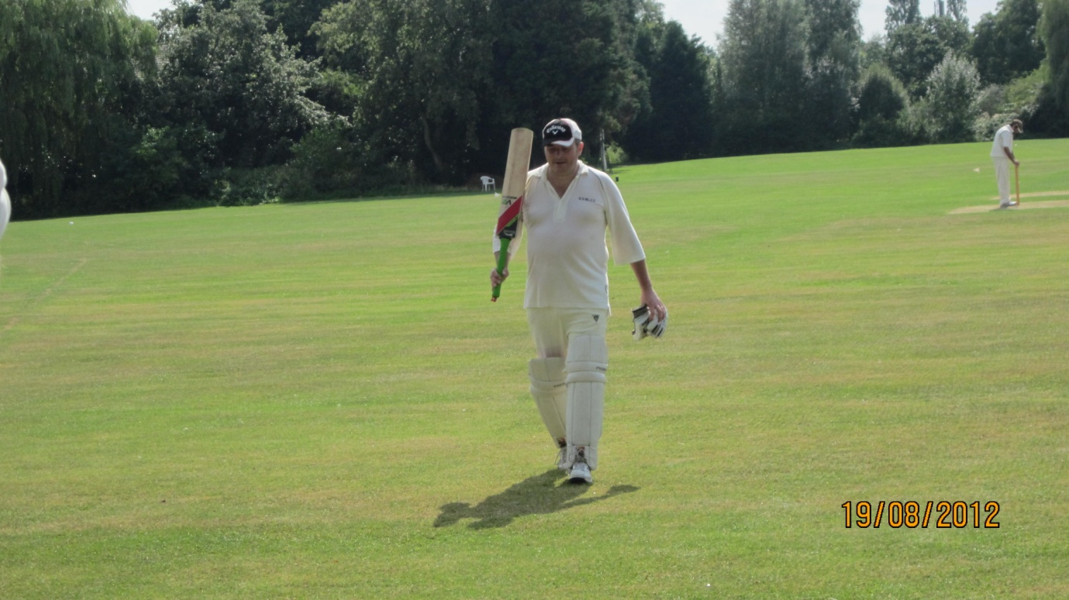 | In 1956, Lancashire’s Cyril Washbrook (1914-1999) was appointed a Test selector. After England had lost the second Test against Australia at Lord’s to go 0-1 down, the 41-year-old was asked by his fellow selectors to leave the room. When he returned, they asked him if he would play in the third Test at Headingley. He made 98, sharing a stand of 187 with Peter May, after England had been reduced to 17-3. England won the game and Washbrook stayed in the team, helping England to win the Ashes 2-1.
Gent 134 said wisely “We somehow don’t think we’ve seen the last of Richard Gilkes in a Gents shirt. It would be good to think that there are a few more blistering fifties to set alongside the six already in the books.” With the perspicacity shown by the 1956 Selectors, the Committee recalled Gilkes to play against Salix. What then happened was remarkable. Not having picked up a bat all season, he scored 93, beating his previous PB of 68 v. West XI in 2009. The Gents posted their sixth highest score. Those present were blessed.

Wright here Wright now

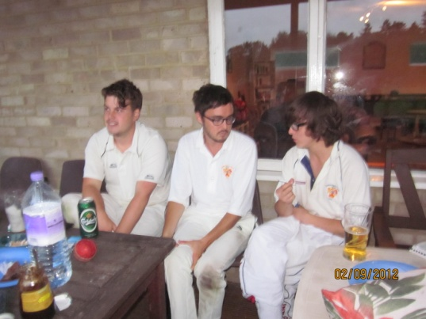 | One year on from Rinku Lall’s 103 against West XI at Crown Taverners, George Wright, 23, took a good Clapham In attack for a brilliant 126 at the same ground. It was an innings exceeded by only four Gents in the 25 season history of the club. On the same day, despite posting a club record 234-3 and recording its first centurion, Judd Street Tigers lost by five wickets at Winchmore Hill when Acme (234-5) scrambled the winning run off the penultimate ball of the match. Chris Wright made 105*, Mike Delanian 45, Chris Dane 31 and Barnaby Pinfield 33*, but it wasn’t enough. That’s 231 runs scored for once out by the unrelated Wrights on the same afternoon. Both scored three sixes off successive balls during their innings.

An astonishing turnaround

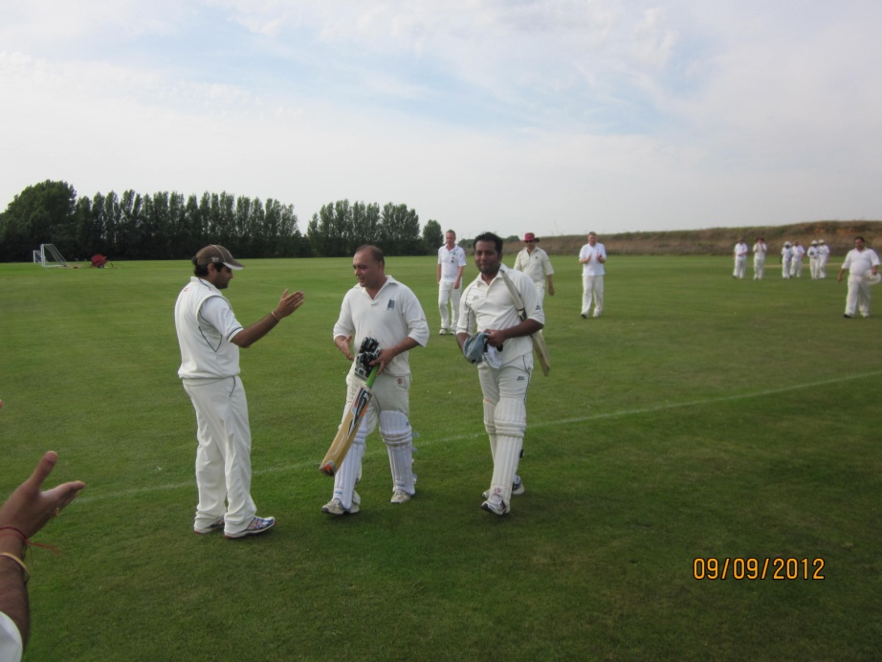 | Old guard and new wave came together with the majestic Patel/Pentakota 10th. wicket stand against Salix on 9 September, dislodging Patel and Toft (Old Grumblers 2009) from the list of partnership records, which is shown later with the other records broken in 2012. With the Gents 173-9, the match was in the balance but the pair batted superbly to add 79.  Himanshu Desai appears more than any other Gent in the records list, three times, each time batting calmly and resolutely while his partner went bonkers, Lall and Sanjay Patel appear twice and 13 players once. Two records date back to 1993 but four were set in the past two seasons.

Not Angry, just disappointed

Whatever the Gents have done on the field of play, the administration of the club has usually run smoothly. The dark moments have been few, though the memory of Salix 2005 still causes shivers:

The game was lost but of more significance was the apocalyptic meltdown of the club’s administration. After the game, Secretary Andrew Burman said he “would rather be convulsed with bird flu than go through that again.” The problems started when 12 Gents pitched up, the constitution of the team being uncertain even on the Sunday morning. That is by no means a rarity but usually an accommodation can be sought with the opposition, but since it then transpired that the Gents had no kit (left in Berkhamsted) and could not even supply a pair of match balls, Captain Sanjay Patel deemed it impolitic to grovel for a 12-a-side game with the Salix skipper.

Before describing the circumstances that led up to the cancellation of the 12 Angry Men game, let us offer a sincere apology to them. It was their only game of the season and their players were coming from far and wide. It is no consolation to our old friends that the Gents have had to pull a game through lack of players only three times before. There was a basis of a team on the Monday prior, but five withdrawals by club regulars before the Wednesday made it impossible to fulfil the fixture. It was even by the standards of Sunday cricket a spectacular haemorrhage. Greg Newcombe tried and tried but with only three players confirmed by the Friday there was only one decision possible. Bank Holiday Sundays are traditionally bad for organisers and perhaps the Gents should not schedule such games in future.

This was not the club’s finest hour. In fact, it was deeply embarrassing. Mark Sciberras’s negotiations five weeks later with Hale (no kit, no match ball and only nine players – what is it about September games?) may have caused him to come out in hives but at least that fixture was honoured. Well done to Hale on finally beating the Gents on their own lovely ground.

Love of the Common people

“Future bright for Hale CC” screamed the Farnham Herald of 5 October after the Gents’ unbeaten run came to an abrupt end. So, season No.25 finished much as season No.1 started, with a defeat batting second. In 1988, the XI was completed by two guests, enigmatically recorded as Mark ? and Richard L. They had not realised that their team had scratched and turned up at Boston Manor, whereupon they were impressed into Gent ranks. They acquitted themselves well but were never heard of again. John Davies, the guest kindly supplied by Hale became the 283rd. Gent in all and the 101st. who has registered just one appearance.

The Herald trumpeted:

Hale beat Gentlemen of West London by 63 runs. The Hale batsmen all made good contributions, especially Naseem, T Walter, Spreadborough, Rees and Mathur, bringing their side to a respectable 172-9 in this 35 overs game. In reply, GOWL struggled against Hale’s opening attack of Davies and Ryan Larby, who took a superb 3 for 14 in his allotted seven overs. M Walter and Giles also bowled well. Hale continued their excellent run, winning easily and look forward to next season with some promising youngsters now coming through.

Around the circuit

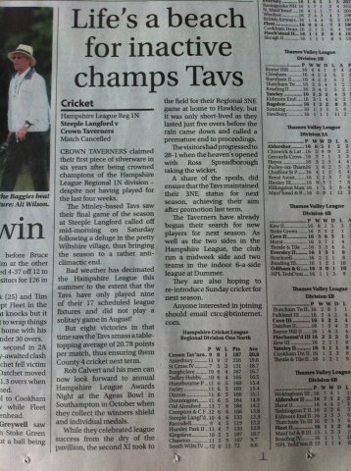 | May we offer our congratulations to Rob Calvert’s Crown Taverners, who won Hampshire League Regional 1N and will play in the County League in 2013. Their August was a washout but by the time the tide receded they were beached far in front of their rivals. The Taverners hope to reintroduce Sunday cricket next year. Let us wish them luck with that and hope that the Gents will still be able to hire a few pitches. Taverners have always made the Gents welcome, indeed nothing is too much trouble for them, and they have our gratitude. It is no coincidence that several players have improved since regular fixtures have been played there. Win or lose, the ground has seen some sparkling cricket.  Winchmore Hill, where JST play their home games, won the Middlesex Premier League, after seven years’ unbroken success for Ealing. A super campaign. Steve Bignell is a regular spectator at the Paulin Ground and has updated Gent House of a Saturday, sometimes taking in two games if there is an early finish. His ultimate goal – attendance at two MPL cricket matches and one Isthmian League football match in one day – is a real possibility for 2013. It is his destiny.

A tragic incident

The Gents have sent their condolences to Judd Street Tigers after a scorebook massacre took place in their game at Winchmore Hill against Potter Street on 16 September. Steve Bignell reported from the crime scene:

As Potter Street were batting, I did not bother with our book and let them get on with it. Suspicions were aroused when a different person had their scorebook every time I looked, many of them very young children. When copying the details to our book, the batting totals were 30 less than their supposed total, the bowling totals 11 less. We had to accept their total as it was such a mess. Fortunately, we didn’t get enough runs to make it a contentious issue. Needless to say, our innings entry was number perfect.

A discrepancy of 30 takes some doing. Young Jordan at Cheltenham needs to set up a school now. Scoring is not hard to do, it just needs concentration and basic intelligence. When done properly it is very fulfilling, yet few are willing to undertake it. The same applies to umpiring – “I don’t know the rules” chunter the refuseniks. First, chum, it’s Laws. Second, your ignorance of same hasn’t stopped you appealing for lbws all afternoon, has it? Why not take a leaf out of Raj Pentakota’s book and perform square-leg umpiring duties in order to learn the ropes? People think a game happens by magic, they really do.

Judd Street Tigers, playing sides mainly from North London and Essex, ended 2012 Won 7 Lost 7 with their top batsmen all ex-West XI players: Wright, Dane, Delanian and Boden. No Gent came near Wright’s total of 489. Whether the two clubs who combined were right to do so is a point of only academic interest, although one frequently discussed. They have done so and that is that. Let’s hope that the 2013 weather permits a meeting.

Sri Lankan off-spinner equals Phil Hill’s record

Congratulations to Ajantha Mendis who recorded the best figures in a Twenty20 international as hosts Sri Lanka thrashed Zimbabwe in the first match of the World Twenty20. With his 4-2-8-6, Mendis equalled the 4-0-8-6 taken by Phil Hill against FC Chad in the August 1996 President’s Cup, the Gents’ best return in the shortened form. With a 10.45 start and the ball seaming violently, all Hill’s victims were taken before the pubs opened. He had a crestfallen Buck lbw 4 and bowled C Russell for 4, Piper for 1 and L Flack, Collings and C Naish for ducks. P Naish scored 10 before Chainsaw Mitchell had him and Wray top scored with 14. Also playing for Chad that day was someone recorded as Smith (uncle of John Emburey). This batting line up was certainly no worse than Zimbabwe’s. Ashton’s Gents overcame Chad’s 48 all out with a stout 49-7 and beat New Barbarian Weasels to lift the cup. Great days. Historians will acknowledge the pioneer Bill Flack, whose invention the President’s Cup was, ten years before the format was contested internationally.

2012 results and fixtures

Date | Gents |  | Result | Judd Street Tigers |  | Result
Sun 22 April | - |  | - | Railway Taverners |  | Cancelled (rain)
Sun 29 April | London Rams |  | Cancelled (rain) | Hadley Wood Green |  | Cancelled (rain)
Sun 6 May | Ramgarhia |  | Lost by 5 wickets | Dinder |  | Cancelled (rain)
Sun 13 May | Cairns Fudge |  | Lost by 3 wickets | Whalers |  | Lost by 6 wickets
Sun 20 May | London Saints |  | Won by 89 runs | Cincinatti |  | Won by 28 runs
Sat 26 May | - |  | - | Entrecasteaux (Twenty20) |  | Won by 64 runs
Sun 27 May | Northfields |  | Lost by 4 wickets | Entrecasteaux |  | Abandoned
Sat 9 June | Birdlip and Brimpsfield |  | Won by 6 wickets | - |  | -
Sun 10 June | Cheltenham Allsorts |  | Won by 6 runs | Potter Street |  | Won by 3 runs
Sun 17 June | Hale |  | Won by 8 wickets | London Saints (18 overs) |  | Won by 65 runs
Sun 17 June | Hale (15 overs) |  | Won by 18 runs | Sunderland SC (18 overs) |  | Won by 7 wickets
Sat 23 June | - |  | - | Plums |  | Cancelled
Sun 24 June | Swinging Googlies |  | Won by 114 runs | - |  | -
Sat 30 June | - |  | - | Dinder |  | Lost by 52 runs
Sun 1 July | Magdalen |  | Lost by 104 runs | Dinder |  | Won by 53 runs
Sun 8 July | Judd Street Tigers |  | Cancelled (rain) | Gentlemen of West London |  | Cancelled (rain)
Sun 15 July | Pak |  | Cancelled (rain) | N2 Casuals |  | Cancelled (rain)
Sat 21 July | - |  | - | Northfields |  | Cancelled
Sun 22 July | Crown Taverners |  | Won by 5 wickets | - |  | -
Sun 29 July | Baker Street Irregulars |  | Won by 7 wickets | Southgate |  | Abandoned
Sun 5 August | St. Anne’s Allstars |  | Won by 113 runs | Octopus |  | Lost by 9 wickets
Sun 12 August | London Saints |  | Won by 91 runs | Eastons |  | Lost by 8 wickets
Sun 19 August | Salix |  | Won by 148 runs | Old Grumblers |  | Lost by 5 wickets
Sun 26 Aug | 12 Angry Men |  | Cancelled | - |  | -
Sun 2 Sept | Clapham In |  | Won by 92 runs | Acme |  | Lost by 5 wickets
Sun 9 Sept | Salix |  | Won by 68 runs | Railway Taverners |  | Won by 140 runs
Sun 16 Sept | - |  | - | Potter Street |  | Lost by 73 runs
Sun 23 Sept | Hale |  | Cancelled (rain) | VCC |  | Cancelled (rain)
Sun 30 Sept | Hale |  | Lost by 63 runs | - |  | -
Record |  | Played 18 Won 13 Lost 5 |  |  | Played 15 Won 7 Lost 7 Abandoned 2
Runs |  | S Patel 274, Dubey 269, Bocha 208, G Wright 178 |  |  | Wright 489, Dane 372, Delanian 246, Boden 232
Wickets |  | S Desai 21, S Patel 15, Pentakota 14, Kumar 11 |  |  | Dane 16, Scally 13, Boden 12, Webster 10
Catches/Stumpings |  | L Wright 2/5, Newcombe/S Patel 6, S Desai 4 |  |  | Dane 7, Wright 6, Rawlings 5/2, Delanian/Webster 4
Games cancelled through lack of players are designated Cancelled. Games rained off are designated Cancelled (rain).

2012 summary match performances and records

6/5 | Ashford | Gents 76 (Ghulum 3-12) Ramgarhia 78-5 (Ali 36, Ash 24, Raghothamreddy 3-17) | Lost by 5 wickets
13/5 | Wandsworth Common | Gents 92 (S Patel 40, Donk 3-19) Cairns Fudge 96-7 (Griffiths 22, Davies 20,  Snelling 3-20) | Lost by 3 wickets
20/5 | Crown Taverners | Gents 224-7 (Inkollu 85*, Newcombe 28, S Desai 22, Cloete 20, van Marle 3-29) London Saints 135-7 (Jones 32, Pearce 32, Sciberras 3-21) | Won by 89 runs
27/5 | Durston House | Gents 125 (Hibbert 27, L Fawkes 3-20, Russell 3-26) Northfields 129-6 (Shill 33) | Lost by 4 wickets
9/6 | Sinclair Field | Birdlip and Brimpsfield 142 (Hieron 54, H Patel 4-29) Gents 143-4 (Cloete 98) | Won by 6 wickets
10/6 | Victoria Ground | Gents 199-8 (Butler 100*, Cloete 34, Khan 22) Cheltenham Allsorts 193 (Cropper 42, White 28, A Waters 27, Ridsdale 26, S Waters 20, S Desai 7-31) | Won by 6 runs
17/6 | Crown Taverners | Hale 93 (Naseem 53, S Desai 4-8, Dubey 3-21)  Gents 96-2 (S Desai 40, de la Perrelle 38*) | Won by 8 wickets
17/6 | Crown Taverners | Gents 128-5 (Khan 26*, Qureshi 25*, Comfort 21)  Hale 110-8 (Calvert 31*, L Wright 3-17) | Won by 18 runs
24/6 | Long Ditton RG | Gents 232-7 dec. (Newcombe 50*, H Desai 43, S Patel 35*, Dubey 26, Hibbert 23)  Swinging Googlies 118 (Rakesh 41, Reuben 22) | Won by 114 runs
1/7 | Old Tenisons | Magdalen 158 (Hogg 37, L Caszo 24, Hart 20, Lall 3-33) Gents 54 (Xavier 5-5) | Lost by 104 runs
22/7 | Crown Taverners | Crown Taverners 151 (Rees 44*, Hayhoe 27, Inkollu 3-19)  Gents 152-6 (Bocha 30, Inkollu 27*, Dubey 21, Lall 20, Worstencroft 3-49) | Won by 5 wickets
29/7 | LMPF Greenford | Baker Street Irregulars 82 (McWilliams 33, Pentakota 4-22, S Desai 3-6) | Won by 7 wickets
 |  | Gents 83-3 (Dubey 41*)
5/8 | Crown Taverners | Gents 249 (G Wright 51, S Patel 45, Jones 36, Bocha 34, Dubey 23, Chadwick 3-29) | Won by 113 runs
 |  | St. Anne’s Allstars 113-9 (MacDonald 43. Hindle 28, Bocha 3-16)
12/8 | LMPF Greenford | Gents 186 (Bocha 76, H Desai 37, Grimes 3-33, van Marle 3-36) | Won by 91 runs
 |  | London Saints 95 (A Mayhew 23)
19/8 | LMPF Greenford | Gents 273-7 (Gilkes 93, Dubey 68, S Desai 44, Ellis 3-54) | Won by 148 runs
 |  | Salix 125 (Spillane 35, Padmore 27, Gavigan 22)
2/9 | Crown Taverners | Gents 202-6 (G Wright 126, Khan 25, Ferreira 3-23) | Won by 92 runs
 |  | Clapham In 110 (Ferreira 54, Clack 37*)
9/9 | Imperial College | Gents 252-9 (S Patel 73*, Dubey 42, Bocha 34, Pentakota 31*, Hibbert 26, Jacobs 5-47) | Won by 68 runs
 |  | Salix 184-7 (Kulasingam 42, Darling 32, Henig 32*, Padmore 22)
30/9 | Hale Common | Hale 172-9 (Naseem 33, T Walter 27, Spreadborough 25, Rees 22)  Gents 109 (Pentakota 30, R Larby 3-14) | Lost by 63 runs

Gentlemen of West London 2012 averages

Player | M. | I. | NO. | R | Av. | Ct./St. | O | M | R | W | Avg.
Bocha | 7 | 7 | 0 | 208 | 29.71 | 2 | 24.5 | 7 | 75 | 6 | 12.50
Caveney | 4 | 3 | 0 | 18 | 6.00 | - | - | - | - | - | -
Cloete | 7 | 7 | 0 | 172 | 24.57 | 2 | 19.5 | 3 | 77 | 3 | 25.67
Comfort | 2 | 2 | 1 | 25 | 25.00 | - | 8 | 1 | 32 | 1 | 32.00
de la Perrelle | 6 | 6 | 2 | 66 | 16.50 | 2 | 18.4 | 2 | 76 | 4 | 19.00
Denton | 3 | 3 | 1 | 6 | 3.00 | - | - | - | - | - | -
H Desai | 7 | 6 | 1 | 101 | 20.20 | 3 | 2 | 0 | 6 | 1 | 6.00
S Desai | 14 | 13 | 0 | 169 | 13.00 | 4 | 43.4 | 1 | 164 | 21 | 7.81
Devunuri | 3 | 3 | 0 | 13 | 4.33 | - | - | - | - | - | -
Dubey | 12 | 13 | 1 | 269 | 22.42 | 1 | 57 | 6 | 232 | 8 | 29.00
Hibbert | 12 | 11 | 0 | 104 | 9.45 | 2 | 34.4 | 3 | 164 | 6 | 27.33
Inkollu | 4 | 4 | 2 | 114 | 57.00 | - | 19 | 0 | 90 | 5 | 47.37
Jones | 8 | 3 | 0 | 46 | 15.33 | 1 | 10 | 1 | 60 | 4 | 15.00
Khan | 6 | 5 | 1 | 74 | 18.50 | 1 | 6 | 0 | 33 | 2 | 16.50
S Kumar | 11 | 8 | 0 | 53 | 6.63 | - | 46.2 | 11 | 146 | 11 | 13.27
Kunche | 2 | 2 | 0 | 22 | 11.00 | - | 1 | 0 | 11 | 0 | N/A
Lall | 4 | 4 | 0 | 36 | 9.00 | 2 | 21 | 3 | 84 | 4 | 21.00
Mangineni | 5 | 4 | 2 | 21 | 10.50 | - | 8 | 2 | 25 | 3 | 8.33
Newcombe | 12 | 9 | 3 | 140 | 23.33 | 6 | 11.2 | 0 | 47 | 4 | 11.75
H Patel | 5 | 4 | 2 | 23 | 11.50 | 1 | 21.4 | 0 | 118 | 7 | 16.86
S Patel | 13 | 13 | 4 | 274 | 30.44 | 6 | 63.4 | 11 | 239 | 15 | 15.93
Pentakota | 7 | 5 | 2 | 73 | 24.33 | 1 | 38 | 4 | 164 | 14 | 11.71
Qureshi | 3 | 1 | 1 | 25 | N/A | 1 | 2 | 0 | 16 | 2 | 8.00
Raghothamreddy | 2 | 2 | 1 | 18 | 18.00 | - | 12 | 2 | 37 | 3 | 12.33
Sciberras | 6 | 3 | 0 | 28 | 9.33 | 3 | 33 | 1 | 133 | 8 | 16.63
Snelling | 2 | 2 | 1 | 12 | 12.00 | 1 | 12 | 2 | 29 | 4 | 7.25
Toft | 7 | 4 | 1 | 5 | 1.67 | - | - | - | - | - | -
Wright G | 3 | 3 | 0 | 178 | 59.33 | - | - | - | - | - | -
Wright L | 9 | 6 | 3 | 34 | 11.33 | 2/5 | 2 | 0 | 17 | 3 | 5.67
Also played (one game only); Bagchi 1/1/1/3, 2-0-6-0, Burman 1/-/-/-, Butler 1/1/1/100, 8-0-37-0 (1 ct.), 8-0-37-0, Davies 1/1/1/10,
Gibson 1/-/-/-, 8-2-24-1, Gilkes 1/1/0/93, Haddow-Allen 1/1/0/3, 3-0-10-1, Herbert 1/-/-/-, P Kumar 1/1/0/0, 4-0-17-1, Palmer 1/1/0/0,
D Patel 1/1/0/2, 1.1-0-6-1, Sidhu 1/1/0/13, Singh 1/-/-/-

Highest score for: 273-7 v. Salix Highest score against: 193 Cheltenham Allsorts
Lowest score for: 54 v. Magdalen Lowest score against: 82 Baker Street Irregulars
Hundred partnerships for (5): 116 Newcombe/Cloete 3rd. wicket v. Birdlip and Brimpsfield 109 H Desai/Bocha 8th. wicket record v. London Saints 108 2nd. wicket Gilkes/S Desai v. Salix 107 Gilkes/Dubey 3rd. wicket v. Salix 100 Inkollu/Newcombe 7th. wicket v. London Saints. Also 79* S Patel/Pentakota 10th. wicket record v. Salix
Hundreds for (2): 126 G Wright v. Clapham In 100* Butler v. Cheltenham Allsorts
Fifties for (8): 98 Cloete v. Birdlip and Brimpsfield 93 Gilkes v. Salix 85* Inkollu v. London Saints 76 Bocha v. London Saints
73* S Patel v. Salix 68 Dubey v. Salix 51 G Wright v. St. Anne’s Allstars 50* Newcombe v. Swinging Googlies
Fifties against (3): 54 Ferreira, Clapham In 54 Hieron, Birdlip and Brimpsfield 53 Naseem, Hale
Four-wicket returns for (3) 7-31 S Desai v. Cheltenham Allsorts 4-8 S Desai v. Hale 4-22 Pentakota v. Baker Street Irregulars
4-29 H Patel v. Birdlip and Brimpsfield
Four-wicket returns against (2): 5-5 Xavier, Magdalen 5-47 Jacobs, Salix
Sixes (56): 9 Cloete 7 Butler, Dubey 6 G Wright 4 Inkollu 3 Bocha, Jones 2 S Desai, Hibbert, Kunche, Newcombe, Khan, L Wright
1 H Desai, Lall, Mangineni, Qureshi, Sciberras
Duck trophy (18): 2 S Desai, Toft 1 Cloete, de la Perrelle, Denton, Devunuri, Dubey, Hibbert, Inkollu, Khan, P Kumar, S Kumar, Lall,
Newcombe, Palmer, Pentakota

Gents manage stalwart absences

2011 2012 +/-  1 H Patel 21 5 -16  2 Caveney 18 4 -14  3 S Patel 17 13 -4  4 H Desai 15 7 -8  5 Sciberras 14 6 -8  6 Toft 12 7 -5  7 Denton 11 3 -8  8 Kumar 11 11 -  9 S Desai 10 14 4  10 Gilkes 10 1 -9 | Forty-two players were used in 2012, six fewer than in 2011, which equalled a record set in 2003. To show how the squad has changed, it is worth comparing 2011 and 2012 appearances. There were 68 fewer by those who played 10 or more in 2011, although fewer games were played. That’s four extra chaps needed every game. Cloete, de la Perrelle, S Desai, Dubey, Hibbert, Jones and Newcombe played more in 2012, new players taking up the rest of the slack. Apart from Hale away, full sides were fielded each game. Thanks are due to the players who took ownership when problems arose.
It is a cricketer’s prerogative to look forward in the close season to future prospects, though it usually ends in tears. Last winter, we fantasised that the Three Rs – Ravi Inkollu, Rinku Lall and Raghu Ragothamreddy – would lead the pace attack. What fire that trio would have possessed, but they did not play together once. Lesson learned, our hope this year is more holistic and is based on a comment some years ago from Richard Gilkes. That everyone renews in 2013 and that a sound bunch of guys continues to have fun.

2012 Played 18 Won 13 Lost 5

Ins Bocha, Butler, Gibson, Kunche, Mangineni, Pentakota, L Wright
Outs Buck, Burford, Iqbal, Rudru

Runs S Patel 274, Dubey 269, Bocha 208, G Wright 178, Cloete 172, S Desai 169, Newcombe 140,
Inkollu 114, Hibbert 104, H Desai 101, Butler 100
Wickets S Desai 21, S Patel 15, Pentakota 14, Kumar 11
Catches Newcombe and S Patel 6, S Desai 4 (L Wright 2 plus 5 stumpings)

The Gents had a fine 25th. season, recovering from some limp early defeats to win 12 of the last 14 games. Only five were lost, half the number suffered in 2010 and 2011. The revolving door span dizzily, but a keen, improving team emerged who relished the opportunities they were given. Runs were scored at the fastest rate ever, 6 per over and conceded at only 4.2. Newcombe took over as Captain in June after H Patel’s resignation and led impressively while adding a notch or two to his own game. The merger of West XI and Walthamstow Horizontals meant the cessation of the Bob Ashton Memorial Cup after 22 seasons. Fears of a resultant lack of focus proved unfounded and the cricket played on tour and twice against Salix was some of the best in recent years. It was mostly a cool, damp summer and only 18 games could be played, the joint lowest since the club began to play every week in 1993. S Patel achieved a significant personal milestone when he became the first Gent to score 5,000 runs. The clouds were injuries, which restricted the appearances of Caveney, de la Perrelle, Denton, H Desai and Toft, fewer appearances from stalwarts Gilkes, Khan, Sciberras and Snelling, the absence of Buck for the first time since 1995 and the cancellation of the 12 Angry Men game due to lack of players.

With H Patel’s withdrawal, the return to India of Devunuri, Inkollu and Ragothamreddy and reduced commitment mentioned above, new players had to be taken on board quickly. Inkollu’s legacy was three gifted players from his Saturday Twenty20 franchise, Mangineni, who soon moved to Lancashire, Bocha and Pentakota. Newcombe brought in the Wright brothers, two men in their early twenties with bags of cricket under their belts. Jones, completing the Cheltenham quartet, played more and proved his ability. The experience of the Desais, Dubey, Hibbert, Khan, Kumar, S Patel and Toft complemented the younger players.

Inkollu and Newcombe rescued the Gents against London Saints but three May games were lost batting first. A successful tour of the Cotswolds then transformed the season. Cloete’s savage 98 against Birdlip and Brimpsfield, guest Butler’s 100 and Sachin Desai’s 7-31 against Cheltenham Allsorts were performances fitting the beautiful scenery and warm hospitality. Hale, who would get revenge in the final game and Swinging Googlies (Newcombe’s maiden fifty) were dispatched before Magdalen span the Gents to their fourth defeat. Inkollu signed off with a sterling display against Crown Taverners, the first of seven consecutive wins. Pentakota and Dubey demolished Baker Street Irregulars before five accomplished batting performances against four teams who had beaten the Gents in 2011: St. Anne’s Allstars (G Wright’s maiden fifty), Salix twice (93 from the returning Gilkes, 68 from Dubey and a record S Patel/Pentakota stand), Clapham In (126 from Wright) and London Saints, when Bocha and H Desai added 109 for the eighth wicket, Desai’s third record stand, more than any other player. Six innings exceeded 200, including three in a row for the first time. Late order stands saw recoveries against London Saints (twice) and Salix from 106-6 to 224-7, 70-7 to 186 and 95-6 to 252-9.

Individual run aggregates were unremarkable, partly due to fewer games (four more matches were played in 2011 and seven more in 2010). Bocha, S Desai, Dubey and S Patel had good all-round returns, but for the first time since 1990 no batsman scored 300, although 11 men over 100 showed the depth of the squad. Eight batsmen made fifties and Butler and G Wright went on to post their maiden hundreds. S Patel headed the batting, five ahead of the breezy Dubey with newcomer Bocha also past 200 in just seven innings. H Desai and Newcombe were consistent, Cloete, Gilkes and G Wright had sublime moments and Jones improved steadily. De la Perrelle, S Desai, Hibbert, Kumar and Lall had quiet batting seasons by their high standards but compensated with their bowling. Inkollu shone on his few appearances before returning to India.

Gents’ bowlers, seamers to a man, absorbed Hemin Patel’s bag of wickets and restricted opponents to an average of 127 runs per innings, reversing the trend since 2009 of 132, 142 and 148. The transformed Sachin Desai took most wickets with Bocha, Dubey, Hibbert, Kumar, S Patel and Pentakota accurate and economical. Dubey’s only over before mid-June went for 19 but thereafter his economy rate plummeted. The hardest bowlers to get away were Bocha and Kumar who bowled at 3.2. Sciberras bowled with guile in his few appearances and dismissed some talented batsmen. The fielding was adequate but too many catches were dropped and only 42 taken. The wicket-keeping was again strong as the Gents were blessed with the athletic and dependable H Desai and latterly L Wright, whose seven dismissals included five stumpings.
Gentlemen of West London v. Salix

Sunday 19 August 2012, LMPF Greenford. Salix won toss. Sunny, 30C

Won by 148 runs

Gentlemen of West London |  |  |  |  | Salix
Denton | c Fletcher |  | b Jacobs | 0 | Rickman |  |  | b Dubey | 0
Gilkes |  |  | b Ellis | 93 | Fletcher |  |  | b Snelling | 2
S Desai | c Collins |  | b Ellis | 44 | †Gavigan |  |  | b S Patel | 22
Dubey |  |  | b Padmore | 68 | *Padmore |  |  | b S Patel | 27
S Patel | c and |  | b Padmore | 14 | Darling |  |  | b S Patel | 0
Jones | c and |  | b Jacobs | 9 | Ellis |  | c S Desai | b Hibbert | 14
Hibbert | lbw |  | b Ellis | 2 | Collins |  |  | b Hibbert | 0
†L Wright | not out |  |  | 9 | Spillane |  | c and | b Newcombe | 35
Snelling | not out |  |  | 11 | Foster (1) |  | c Snelling | b S Desai | 0
*Newcombe | dnb |  |  |  | Jacobs |  | not out |  | 17
Toft | dnb |  |  |  | Foster (2) |  |  | b Newcombe | 0
Extras |  |  | 9nb 7w 3b 5lb | 24 | Extras |  |  | 1nb 5w b2 1lb | 9
Total | 35 overs |  | 7 wickets | 273 | Total |  | 34.2 overs | All out | 125
FoW: 0, 108, 215, 225, 238, 245, 253 |  |  |  |  | FoW: 0, 8, 36, 36, 60, 60, 72, 73, 125, 125
Bowler |  |  |  |  | Bowler
Jacobs | 7-0-53-2 |  |  |  | Dubey | 7-1-21-1
Darling | 7-0-40-0 |  |  |  | Snelling | 7-1-17-1
Padmore | 7-0-44-2 |  |  |  | S Patel | 7-0-27-3
Ellis | 7-0-54-3 |  |  |  | Hibbert | 3.4-0-26-2
Foster | 7-0-76-0 |  |  |  | S Desai | 5.2-0-14-1
 |  |  |  |  | Newcombe | 4.2-0-18-2
An astonishing turnaround in the Gents’ fortunes against this tough opposition saw a convincing win on a hot, humid day. The hosts survived the loss of Denton second ball to lodge, for only the second time after London Rams in 2005, two century stands in an innings. Gilkes (93 in 27 overs with 10 fours in his first game of 2012) and Dubey (68 in only 10 overs with 12 fours and a six) posted personal bests for the club although Desai’s elegant 44 (six fours) was no less important a contribution in a total exceeded only five times in the club’s history. Dubey and Snelling then wore Salix down with accurate opening spells and well though they fought the result was inevitable from the tenth over, with the score 15-2 and the required run rate over 10.

With the welcome return of Gilkes, Denton and Snelling, it was something of a Legends XI, prompting Denton to enquire whether it was Sanjay Patel’s testimonial. It was an older side than normal, though three players were 23 or younger. Only Gilkes from the September 2011 Gents/Salix clash played here, compared to seven Salix. The talk among the wiseacres was of another low-scoring game, with the early cloud cover, unpredicted by the Meteorological Office, certain to help the side bowling first.

To Newcombe’s surprise, Padmore inserted the Gents. Denton blocked the first ball, had the sightscreen moved then showed the value of his work in the gym by contorting his body enough to pop a leg-side delivery high to slip. Gilkes and Desai then constructed a masterful stand of 108 in 17 overs before Desai chipped Ellis’s slow left-arm to long on. Gilkes went powerfully on but the second-wicket stand was dominated by Dubey’s booming drives, his six off Foster the only maximum of the innings. Padmore may have rued his decision to insert the Gents but his bowlers and fielders did little wrong. Sometimes batsmen take control and the fielding side is powerless to prevent a rampage. Gilkes, Desai and Dubey were irresistible and bright hitting by Patel, Jones, Hibbert, Wright and Snelling brought up an impressive final total. With his brilliant 93, Gilkes’s career aggregate overtook Buck’s, prompting the best captain the Gents never had to seek out his whites with a view to a return. His conditions are three: a South London game played on a Saturday under his captaincy.

Dubey bowled Rickman with the third ball of the innings and Snelling bowled Fletcher in his fourth over. Gavigan and Padmore recovered well but the accuracy of Patel and Hibbert proved decisive as Salix counterattacked. Desai at gully pouched Ellis the ball after a six had disappeared over the mid-wicket boundary as wickets fell regularly. Hibbert was injured trapping a drive with his foot, Desai completing the over. Fletcher kindly bandaged him. Spillane and Jacobs battled hard with a stand of 52 for the ninth wicket before Newcombe struck with successive balls, as Patel and Hibbert had done before him.

Salix were good fun before, during and after the game and it is hoped that they will forgive occasionally loud cavorting on a day when everything went right for the Gents, from a surprising insertion to risky but attractive strokeplay and finally a breeze which provided a little comfort in the second innings. Farewell to Greenford it is then, a venue which has seen three wins out of three in 2012.
Gentlemen of West London v. Clapham In

Sunday 2 September 2012, Crown Taverners. Gents won toss. Cloudy, 19C

Won by 92 runs

Gentlemen of West London |  |  |  | Clapham In
Khan | c Clack | b Ferreira | 25 | *Ferreira | c Qureshi | b S Patel | 54
G Wright |  | b Plaja | 126 | Gregory | run out |  | 2
Dubey | c and | b Ferreira | 4 | Plaja |  | b Bocha | 0
*Newcombe |  | b Wildman | 0 | Wildman |  | b Bocha | 0
Bocha | c Gregory | b Ferreira | 10 | Boa |  | b Dubey | 0
Kumar | c and | b Morgan | 19 | †Clack | not out |  | 37
S Patel | not out |  | 7 | Curtis | lbw | b Kumar | 4
†L Wright | not out |  | 1 | Morgan |  | b Kumar | 0
Hibbert, Qureshi and Toft dnb
Extras |  |  | 2nb 2w 4b 3lb | 11 | Extras |  |  | 7w b2 4lb | 13
Total | 35 overs |  | 6 wickets | 202 | Total |  | 27 overs | All out | 110
FoW: 59, 63, 66, 106, 150, 194 |  |  |  |  | FoW: 20, 20, 20, 21, 94, 110, 110
Bowler |  |  |  |  | Bowler
Morgan | 7-0-31-1 |  |  |  | Dubey | 7-1-21-1
Boa | 7-1-24-0 |  |  |  | Bocha | 7-1-25-2
Wildman | 7-0-34-1 |  |  |  | Hibbert | 4-0-24-0
Ferreira | 6-1-23-3 |  |  |  | S Patel | 6-1-21-1
Curtis | 4-0-38-0 |  |  |  | Kumar | 3-0-13-2
Gregory | 3-0-41-0
Plaja | 1-0-5-1

The Gents beat a Clapham In side bereft of three players at humid Crown Taverners. George Wright scored his maiden century (21 fours, three sixes) as the hosts exceeded 200 for the fifth time this season. Clapham then lost three wickets in one Bocha over and well though Ferreira and Clack batted the task proved beyond them. The second innings was notable for an attack on the players by flying ants, probably black garden ants, Lasius niger; nature’s revenge, perhaps, for the murder of a mole by the groundsman before the match. The players were lucky that the plot of the 1978 Australian horror film Long Weekend was not more fully reprised. The tagline for this film was “Their crime was against nature...and nature found them guilty!”

Newcombe lent a fielder to the visitors and the match started on time at 1.45pm. Khan returned for his first game since June to open with Wright, 59 runs being put up in 15 overs of good cricket against an excellent attack. Ferreira’s spin then induced a tickle to the ’keeper by Khan and a return catch drilled second ball by Dubey. Newcombe soon followed and three wickets had tumbled for seven runs. Clapham In sniffed blood.

Bocha, Kumar and Patel then supported Wright to the hilt in a series of sensible stands. Wright’s innings was outstanding. He had moved to 99 when Gregory began his second over, the 33rd. of the innings. The first four balls went for a four followed by three sixes into the trees. He fell to Plaja in the next over but the Gents sought 200 and Patel and Wright secundus got them there. The total would certainly have been reduced had Clapham had eleven but perhaps not by many. Ferreira, the pick of the bowlers, set wise fields and his men and the Gent loan players (including the irrepressible Wright secundus, in borrowed tracksuit bottoms that nearly fitted) backed him up. The pitch offered its usual consistent bounce and Wright primus was venomous with his hook and pull off anything short, most of his boundaries being over the ropes in a flash. Little could have been done to stop him. It was a privilege to witness such an innings.

Clapham In began soundly, the left-hander Ferreira driving three fours, until the innings unravelled in the sixth over, Bocha’s third. Both batsmen ended up at the bowler’s end after the first ball and Bocha’s calm throw to Wright saw the end of Gregory. Bocha then with the fourth and sixth balls bowled Plaja and Wildman, whose 76 was a match-winner in the corresponding 2011 clash. Dubey bowled Boa and it was 21-4. Ferreira and Clack then batted very well. Their stand of 73 took 17 overs but the final three had seen runs scored at the required rate before the captain fell to a well-judged catch by Qureshi on the long-off boundary. He had struck 10 fours. Kumar took two wickets in two balls to end the game at 6.40pm.

It is hoped that this fixture can be renewed in 2013, perhaps with home and away games. Although beset by absences due to the England v. South Africa ODI and a late withdrawal due to injury, Ferreira and his men left a dignified impression and were no mean cricketers. A captain who dons his club blazer to toss up sets a standard of decorum which was a rare pleasure to witness. George Wright’s 126 will never be forgotten and was a fitting way to wave goodbye to Crown Taverners for another year. This was the club’s sixth successive win.
Salix v. Gentlemen of West London

Sunday 9 September 2012, Imperial College, Harlington. Gents won toss. Sunny, 28C

Won by 68 runs

Gentlemen of West London |  |  |  |  | Salix
G Wright |  |  | b Jacobs | 1 | Rickman |  | c S Patel | b Pentakota | 5
Denton |  |  | b Jacobs | 2 | †Gavigan |  |  | b Pentakota | 16
*S Desai | c Gavigan |  | b Jacobs | 7 | Kulasingam |  |  | b Kumar | 42
Dubey | c Gavigan |  | b Jacobs | 42 | *Padmore |  | c Bocha | b Hibbert | 22
Bocha | lbw |  | b Jacobs | 34 | Darling |  | c and | b S Patel | 32
Kumar | lbw |  | b Kulasingam | 2 | Jamieson |  | c Wright | b Hibbert | 4
S Patel | not out |  |  | 73 | Henig |  | not out |  | 32
Hibbert | lbw |  | b Darling | 26 | Heaton |  |  | b S Patel | 0
Kunche | c Gavigan |  | b Jamieson | 12 | Foster |  | not out |  | 2
†L Wright | c Henig |  | b Jamieson | 2 | Fletcher |  | dnb
Pentakota | not out |  |  | 31 | Jacobs |  | dnb
Extras |  |  | 5nb 10w 4b 1lb | 20 | Extras |  |  | 6nb 18w 4lb 1b | 29
Total | 35 overs |  | 9 wickets | 252 | Total |  | 35 overs | 7 wickets | 184
FoW: 2, 8, 36, 88, 95, 95, 136, 171, 173 |  |  |  |  | FoW: 5, 57, 98, 102, 113, 149, 157
Bowler |  |  |  |  | Bowler
Jacobs | 7-1-47-5 |  |  |  | Dubey | 6-0-35-0
Foster | 4-0-26-0 |  |  |  | Pentakota | 6-0-24-2
Padmore | 6-0-56-0 |  |  |  | Kumar | 7-1-34-1
Kulasingam | 6-0-37-1 |  |  |  | Hibbert | 7-1-34-2
Heaton | 6-0-28-0 |  |  |  | S Patel | 3-0-17-2
Darling | 3-0-26-1 |  |  |  | S Desai | 4-0-18-0
Jamieson | 3-0-27-2 |  |  |  | Bocha | 2-0-17-0

A plot seen before in 2012 was repeated as the Gents recovered from 95-6 to post 252-9, thus exceeding 200 in three successive games for the first time. S Patel (11 fours) made his highest score since 2006 and Pentakota (five fours) a personal best for the club to set a new club 10th. wicket record, 79 in just 10.3 overs. Salix batted well in plummeting temperatures against sometimes torrid bowling to record a score that would win many matches but here left them 68 short. They were fine opponents, the equal of the Gents for most of the afternoon, but were undone by a stand that will live long in the memory. The late summer London Buses rubber therefore yielded 834 runs, 525 to the Gents who won both games after years of dismal results in this series.

Desai won the toss and batted on a fast, true pitch. Wright was bowled fifth ball for 125 less than a week before by Jacobs, Denton following the first ball of his next. Off the remaining five balls, Dubey calmly played himself in with four fours and a towering six over extra cover which may have been the season’s longest carry. A charge of eccentricity can justifiably be lodged against a score of 31-2 off three overs which soon became 36-3 when Desai edged behind. Dubey (six fours, two sixes) and Bocha (seven fours) put up 52 in six overs but Jacobs had them both to card 5-47 before Kumar fell, the second of three lbws, to leave the Gents 95-6 off 13 overs.

By now Patel was at the crease. He batted quite brilliantly for 22 overs, during which 157 runs were added. He had had a quiet season up to this game but one writes him off at one’s peril. Come the last knockings of summer and there he is. Hibbert, back to his best, impressed with four fours and a six, Kunche smote briefly with a four and a six and Wright lobbed one up to short mid-wicket. That was 173-9 after 25 overs. Patel was in complete control and trusted his partner from the off. Pentakota changed his bat early in the piece, borrowing Hibbert’s railway sleeper. Fours, mainly straight, through point and cover, pinged to the chalk line. The running was exemplary. In the 32nd. over came the fifty stand, the previous record of 57 was left behind in the 34th. over and a final flurry brought up 252. Gavigan took three catches at the wicket. Patel claimed at tea to have been inspired by the band playing at the Sri Lankan sports festival on the top pitch, which included cricket and tug of war. Others thought that the music was lifted from the Equity backing tapes endemic to 1960s Swinging London movies, lacking only David Hemmings grooving away with a chick in a discotheque.

The Gents’ two heroes were called into early action in the reply, Rickman lofting to cover in the second over. Gavigan, dropped early at the wicket, gave Kulasingam support but Dubey and Pentakota bowled steadily and the required run rate, 7.2 at the start of the dig, began to rise. Gavigan played on and Desai chose to bowl Kumar and Hibbert through. Kumar has bowled his medium pace at under three rpo in 2012. He was more expensive here but was within the contingency calculated by Desai. As was Hibbert who, taken for 18 in his second over, peppered his tormentor Kulasingam with a series of nasty short pitches that the batsmen did well to play down. Hibbert had Padmore and Jamieson caught and Kumar bowled the bruised Kulasingam. Patel, whose day this was, took two good late wickets while Henig drove to great effect, if too late to affect the result.
Hale v. Gentlemen of West London

Sunday 30 September 2012, Hale Common. Hale won toss. Cloudy, 15C

Lost by 69 runs

Hale |  |  |  |  | Gentlemen of West Londondavies
Davies | run out |  |  | 11 | Dubey (1) |  |  | b Davies | 0
T Walter |  |  | b Cloete | 27 | S Desai |  |  | b Giles | 12
Naseem |  |  | b S Desai | 33 | Mangineni |  | c | b R Larby | 8
Rees | c S Desai |  | b Pentakota | 22 | Cloete |  |  | b R Larby | 4
Spreadborough | run out |  |  | 25 | Bocha |  |  | b R Larby | 7
Nikhil | run out |  |  | 19 | S Patel |  | c | b M Walter | 13
Weaver | st Wright |  | b Cloete | 2 | *Sciberras |  | lbw | b M Walter | 9
Giles | st Wright |  | b S Desai | 0 | Pentakota |  | run out |  | 30
R Larby | run out |  |  | 10 | †Wright |  | c | b Giles | 2
L Larby | not out |  |  | 6 | Davies |  | not out |  | 10
M Walter | not out |  |  | 6 | Dubey (2) |  | c | b Weaver | 7
Extras |  |  |  | 11 | Extras |  |  |  | 1
Total | 35 overs |  | 9 wickets | 172 | Total |  | 30 overs | All out | 103
FoW: N/R |  |  |  |  | FoW: N/R
Bowler |  |  |  |  | Bowler
Bocha 7-4-11-0, Sciberras 5-0-20-0, Dubey 5-0-29-0, S Desai 6-0-27-2, S Patel 5-0-24-0, Pentakota 5-0-34-1, Cloete 2-0-9-2 | N/R

A nine-man Gents were comfortably beaten by a strong Hale side in the last game of the season at chilly Hale Common writes Mark Sciberras. Kumar and Hibbert both pulled out at the last minute through illness (we wish them well) with no replacements forthcoming, even with the best efforts of Burman and several other players. To further complicate matters for reasons which can only be described as unfathomable, the Gents’ kitbag was unavailable having been left at Hemin Patel’s despite numerous rescue attempts.

So not the best start to a game, although after asking to borrow kit and then apologising for the lack of players, match balls and a scorebook, Captain Sciberras successfully managed to negotiate with Hale’s captain Weaver a loan player in Hale’s John Davies and the return of the Gents’ lowest-scoring top six batsman to return at No. 11. A further diplomatic incident was avoided when the 40 over game proposed by Hale was politely declined in favour of the more traditional 35, on the basis that it was now almost 12.30 and it would be dark as the second innings got started. Unsurprisingly the Gents lost the toss and Hale elected to bat on what looked like a good and true wicket for the time of year.

Hale’s openers Davies and Walter (Senior) were comfortable against Sciberras although Bocha was more penetrative, runs mainly coming off the edge. They lasted nine overs until Boycottesque running from Walter ended his partner’s innings. Naseem was dropped first ball by Pentakota off a full-blooded drive to mid-off, resulting in Walter’s most prudent nugget of advice amongst many throughout the day of “You’ll regret that”. So it proved, as Naseem went on to top score with a quick 33 until he was bowled Desai, the Gents’ best bowler on the day. Hale’s running between the wickets looked suspect, even before Spreadborough clattered into wicket-keeper Wright (almost rendering him unconscious) attempting a quick single. He was soon to be run out for 25 while Rees, so often the danger man against the Gents was comfortably caught by Desai at mid-wicket off Pentakota. Two further Hale wickets fell to run outs and two to stumpings, Mathur’s 19 being the only other innings of note. Tight bowling towards the end of the innings from Desai, Pentakota and Cloete restricted Hale to 172-9. Although this looked slightly above par, the Gents felt that their 10 men had battled well.

With S Patel, Dubey and Bocha competing to be the season’s top run scorer, all were given at least a top-six slot. Dubey fell early, driving to mid-off after losing patience to Davies’ spin. It was perhaps understandable as the pace of his opening partner Larby was virtually unplayable. Desai played sensibly for his 12 and Mangineni looked good until he was caught off Larby for 8. Cloete hit an almighty four and was out next ball, while Bocha became Larby’s third and final victim. The middle order of Patel and Sciberras got starts but were unable to consolidate the innings. Wright fell cheaply after being hastily woken on the boundary to get his pads on, whilst Pentakota batted beautifully to restore some Gents pride with a well-deserved 30. He was unfortunate to fall after being sent packing to the danger end attempting a quick single by guest Davies, who up until then had offered excellent support. Despite an almighty six which almost made it to the Ball and Wicket, Dubey was unable to capitalise on his second chance, although the Gents had at least made it over the hundred mark with 103 all out. So an enjoyable yet slightly disorganised day ended amicably in the Ball and Wicket, the Gents players happy to squeeze a final day’s cricket out of the season and Hale content to get one over on the Gents levelling the games this season at one apiece.

Updated club records

Highest partnerships by wicket by Gents (* = unbroken)
1 | 121 | Bignell (34) and Hubbucks (78) v. Enterprise | Victoria RG | 2 May 1993
2 | 127 | H Desai (34) and Lall (61) v. Ham and Petersham | Crown Taverners | 7 August 2011
3 | 166 | Husain (100*) and Kain (87) v. London Saints | Old Tenisons | 6 June 2007
4 | 162 | H Desai (46) and Lall (128) v. London Saints | Old Haberdashers | 14 August 2011
5 | 152 | Ashton (102) and Hughes (57*) v. London Saints | Victoria RG | 15 August 1993
6 | 100 | S Patel (100*) and Bhatt (51) v. London Rams | Belair Park | 3 July 2005
7 | 110* | Thompson (66*) and Derriman (47*) v. London Rams | Belair Park | 3 July 2004
8 | 109 | H Desai (37) and Bocha (76) v. London Saints | LMPF Greenford | 12 August 2012
9 | 108 | Hibbert (81) and Sciberras (22) v. Brondesbury Casuals | Shepherd’s Bush | 17 September 2000
10 | 79* | S Patel (73*) and Pentakota (31*) v. Salix | Imperial College | 9 September 2012

Highest partnerships by wicket by opponents (* = unbroken)
1 | 239* | Bulmer (140*) and Maddocks (87*) (London Owls) | Victoria RG | 5 September 1993
2 | 160 | Branch (50*), Susman (50*) and Stanier (37) (Bedouins) | Enville | 6 August 2006
3 | 215 | Heyman (132) and Jones (89) (Village XI) | Old Hamptonians | 30 July 2006
4 | 138 | Jaques (107) and Torbe (65) (East Harrow Cheetahs) | Beverley Park | 4 August 1996
5 | 90 | Junani (74) and Ahluwalia (49) (Gubbays) | Cavendish RG | 2 September 2007
6 | 100 | Dane (73) and Walton (53) (West XI) | KGF Morden | 10 September 2000
7 | 82 | Wildman (76*) and Thomson (14) (Clapham In) | Old Tenisons | 3 July 2011
8 | 64 | Nicol (31) and Evans (56) (St. Anne’s Allstars) | Barnes Common | 29 April 2006
9 | 68 | Heafield (40) and Wall (19) (London Rams) | Belair Park | 28 July 2001
10 | 52 | Dimond (37) and Heap (11*) (Enterprise) | Victoria RG | 31 August 1997

Highest totals – Gents
325-5 London Saints (Old Tenisons, 3 June 2007) ⁴⁰ ^{overs}
290-3 London Rams (Old Tenisons, 25 June 2006) ³⁵
281-7 New Barbarian Weasels (Fairfield RG, 7 July 2007) ³⁵
279-3 West XI (Crown Taverners, 4 September, 2011) ³⁰
275-3 Sloane Club (Burton’s Court, 11 May 2008) ³⁵
273-7 Salix (LMPF Greenford, 19 August 2012) ³⁵
266-5 London Saints (Old Haberdashers, 14 August 2011) ³⁵
264-6 London Rams (Belair Park, 3 July 2005) ³⁵
261-4 dec. New Barbarian Weasels (Victoria RG, 15 July 2001) ³⁹
256-5 dec. London Owls (Victoria RG, 31 July 1994) ³⁹

Highest totals – opponents
284-3 12 Angry Men (Victoria RG, 29 July 2001) ^{40 overs}
263-6 West XI (Victoria RG, 24 May 1992) ⁴⁰
256-5 Village XI (Old Hamptonians, 30 July 2006) ³⁵
252-5 Village (Fairfield RG, 5 September 2010) ⁴⁰
251-7 Old Tenisons Taverners (Old Tenisons, 4 July 2010) ⁴⁰
242-5 Rotherham SC (Battersea Park, 7 May 1995) ³⁵
240-6 Brentham (Brentham, 30 August 2010) ³⁹
239-0 London Owls (Victoria RG, 5 September 1993) ^{37.5}
231-3 12 Angry Men (Victoria RG, 3 September 2000) ⁴⁰
227 New Barbarian Weasels (Victoria RG, 26 July 1998) ^{44.3}
227-6 West XI (Victoria RG, 2 June 2002) ³⁵

Lowest all-out totals – Gents
51 London Owls (Gunnersbury Park, 5 May 1991) ^{Batting first, game won}
54 East Harrow Cheetahs (Cranford Park, 27 May 1989) ^{Batting second, game lost}
54 Magdalen (Old Tenisons, 1 July 2012) ^{Batting second, game lost}
55 Brondesbury Casuals (Brondesbury, 7 September 2003) ^{Batting first, game lost}
57 West XI (HSBC, 7 September 2008) ^{Batting second, game lost}
58 Sunderland SC (Arnos Park, 5 July 1997) ^{Batting second, game lost}
59 Wombles (Victoria RG, 30 August 2009) ^{Batting first, game won}
60 West XI (Victoria RG, 29 May 2005) ^{Batting second, game lost}
62 London Saints (9 June 2001), Exiles (5 August 2001) and Purley Arms (29 June 2008) Batting second, second and first, games lost

Lowest all-out totals – opponents
17 Enterprise (Victoria RG, 8 September 1991) ^{Batting second, game lost}
17 London Canaries (Victoria RG, 1 July 2001) ^{Batting second, game lost}
29 Old Cubbonians (Wandsworth Park, 5 May 1993) ^{Batting second, game lost}
30 Sloane Club (Burton’s Court, 11 May 2008) ^{Batting second, game lost}
32 Enterprise (Victoria RG, 22 May 1994) ^{Batting first, game abandoned}
35 London Saints (Fairfield RG, 17 May 2009) ^{Batting first, game lost}
37 Enterprise (Long Ditton RG, 13 July 1997) ^{Batting second, game lost}
40 Enville (Kinver School, 14 August 2004) ^{Batting second, game lost}

Hundreds – Gents
158* Jones v. West XI (Gunnersbury Park, 21 July 2002)
143* Husain v. New Barbarian Weasels (Fairfield RG, 7 July 2007)
137* Ashton v. Enterprise (Victoria RG, 10 May 1992)
128 Lall v. London Saints (Old Haberdashers, 14 August 2011)
126 G Wright v. Clapham In (Crown Taveners, 2 September 2012)
109 Husain v. New Barbarian Weasels (CSSC Chiswick, 7 June 2008)
104* Husain v. New Barbarian Weasels (King’s College, 11 June 2005)
103 J Wright v. 12 Angry Men (Victoria RG, 3 September 2000)
103 Husain v. London Saints (Old Haberdashers, 4 June 2006)
102 Ashton v. London Saints (Victoria RG, 15 August 1993)
102 J Wright v. Wandham (Fire Brigade Epsom, 14 May 2000)
102* Buck v. New Barbarian Weasels (Victoria RG, 15 July 2001) ^{Retired hurt}
102 Lall v. West XI (Crown Taverners, 4 September 2011)
100* J Wright v. London Canaries (Victoria RG, 25 June 2000)
100* S Patel v. London Rams (Belair Park 3 July 2005)
100* Husain v. London Saints (Old Tenisons, 3 June 2007)
100* Butler v. Cheltenham Allsorts (Victoria Ground, 10 June 2012)

Hundreds – opponents
150* Walker (Rotherham SC) (Battersea Park, 7 May 1995)
140* Bulmer (London Owls) (Victoria RG, 5 September 1993)
132 Heyman (Village XI) (Old Hamptonians, 30 July 2006)
113 Griffiths (Hale) (Hale Common, 27 September 2009)
112* AN Other (East Harrow Cheetahs) (Marble Hill Park, 19 June 1988)
111 Groves-Loader (New Barbarian Weasels) (Victoria RG, 26 July 1998)
107 N Wilson (Wandham) (Beverley Park, 5 June 1994)
107 Jaques (East Harrow Cheetahs) (Beverley Park, 4 August 1996)
103* Best (New Barbarian Weasels) (Peel Centre, 1 September 1991)
102 Hadfield (12 Angry Men) (Victoria RG, 29 May 1994)
101 Mayhew (London Saints) (Beverley Park, 17 August 1996)
101* Atkins (Exiles) (Victoria RG, 5 August 2001)
100 D Wilson (12 Angry Men) (Victoria RG, 29 July 2001)

Best bowling returns – Gents
8-33 Snelling v. 12 Angry Men (Albert Road RG, 16 May 1999)
8-77 Snelling v. East Harrow Cheetahs (Beverley Park, 4 August 1996)
7-31 S Desai v. Cheltenham Allsorts (Victoria Ground, 10 June 2012)
7-44 Ashton v. Enterprise (Victoria RG, 5 May 1996)
7-55 Ashton v. New Barbarian Weasels (King’s College, 18 June 1994)
6-6 Snelling v. London Canaries (Victoria RG, 1 July 2001)
6-8 Hill v. FC Chad (King’s College, 25 August 1996)
6-15 Ashton v. East Harrow Cheetahs (Cranford Park, 27 May 1989)
6-16 D Patel v. Urban Associates (Victoria RG, 20 May 2001)
6-24 Snelling v. 12 Angry Men (Victoria RG, 11 July 1999)

Best bowling returns – opponents
6-10 High (Enterprise) (Gunnersbury Park, 8 September 1991)
6-13 Phillips (Virgin Casuals) (Victoria RG, 3 August 1997)
6-16 Rafiq (Robin Hood) (Sutton Common RG, 27 June 1999)
6-24 Crawford (St. Anne’s Allstars) (Victoria RG, 29 August 2004)
6-25 Arthur (West XI) (Boston Manor, 17 June 1989)
6-25 Boa (Village) (Fairfield RG, 5 September 2010)
6-28 Gathercole (Urban Associates) (Wimbledon Park, 13 August 1995)
6-31 Griffiths (London Saints) (Victoria RG, 29 August 2004)
6-38 Baker (Sunderland SC) (Victoria RG, 17 June 2006)
  - Kirkwood (New Barbarian Weasels) (Alexandra RG, 30 July 1995)

Top 10s from the first 25 years 1988-2012

Games |  | Runs |  | Wickets
S Patel | 276 | S Patel | 5,194 | Snelling | 386
Snelling | 235 | Ashton | 3,848 | S Patel | 340
Buck | 214 | D Patel | 3,154 | D Patel | 229
Burman | 211 | Wright | 3,020 | Ashton | 222
D Patel | 190 | Husain | 2,270 | H Patel | 207
Sciberras | 165 | Gilkes | 1,845 | Todd | 148
Ashton | 153 | Buck | 1,792 | Sciberras | 143
Wright | 149 | Boddington | 1,422 | Wright | 135
H Patel | 147 | Sciberras | 1,416 | Buck | 113
Todd | 147 | Snelling | 1,300 | Boddington | 98

Celebrity cricket in the era of the blazer

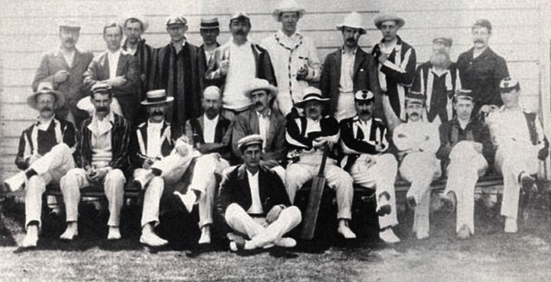  Back row from left to right: E.W. Hornung of Raffles fame, author and poet E. V. Lucas, P.G.Wodehouse, J.C. Smith, G. Charne, Sir Arthur Conan Doyle, big game hunter Hesketh-Hesketh Prichard, illustrator L. D. Luard, painter C. M. Q. Orchardson, landscape and flowers painter Leonard Charles Nightingale, A. Kinross.  Front row from left to right: C. Gascoyne, author Shan F. Bullock, painter G. Hillyard Swinstead, architect Reginald Blomfield, the Hon. W. J. James, American illustrator and painter Edwin Austin Abbey, painter Albert Chevalier Taylor, J. M. Barrie, German-English poet, criminologist George Cecil Ives and painter George Spencer Watson.  Sitting on ground: author and politician A. E. W. Mason, best remembered for his novel Four Feathers. | The creator of Peter Pan, Sir James M. Barrie (1860-1937), was an enthusiastic cricketer and assembled the most extraordinary amateur cricket team ever to take the field. Some of Edwardian England’s most famous authors including Arthur Conan Doyle, A. A. Milne, P. G. Wodehouse, and Jerome K. Jerome, regularly turned out for Barrie’s team from 1890 to 1913, when the team was brought to an end by the First World War.  The team was named Allahakbarries in the mistaken belief that ‘Allah akbar’ meant ‘Heaven help us’ in Arabic (rather than ‘God is great’). Team selection criteria were based more on celebrity status than talent, although in Conan Doyle, both converged.
Barrie had to explain the Laws of the game including which side of the bat to wave at the ball to woolly author Augustine Birrell (later First Secretary for Ireland during the Easter Rising), en route to his first match. Yet, Barrie was extremely proud of (and also simultaneously amused by) his talentless team and wrote a book about it, titled Allahakbarries C.C. and dedicated it ‘To Our Dear Enemy Mary de Navarro’, the famous American stage actress Mary Anderson, who once bowled him out. Barrie himself, an unathletic and frail Scot was no better at the game, although he once bowled out Douglas Haig, later the Commander of the British Expeditionary Force in World War One.

Absent from the picture taken in 1903 were big names like Rudyard Kipling, H. G. Wells, Milne or Jerome (all were part of the group at times), but it was still a respectable collection of artists none the less. Mason introduced Barrie to Hesketh-Hesketh Prichard and Robert Falcon Scott, two greatest explorers of the day. Barrie, seemingly forever lost in fantasy, had deep fascination with explorers.

A personal message

Gentlemen of West London CC has been playing for 25 seasons and on 22 May 2013 will celebrate its Silver Jubilee. What started as a small group of friends playing a few games of cricket has changed through the administrations of one Monarch, five Prime Ministers and 15 England Test Captains (Gatting was replaced in June 1988) to a larger group of friends playing cricket every week. The ethos has remained the same but the personnel have changed. Back in the day it was all organised by landline telephone, letter and bullying by the indomitable Mark Ashton (oh to have recorded some of those calls!), methods that were no less efficient than the electronic media used today.

I would like to thank all those who have made it possible. Don’t worry, this is not an Oscar acceptance speech, but it would be wrong not to acknowledge our founding father Mark Ashton, his brother Bob, always 24 in my mind’s eye, Dhruv, Hemin and Sanjay Patel, Stuart Snelling, Tony Buck, Mark Sciberras, Jim Wright, Ken Toft, Richard Gilkes, Steve Bignell and the wise current Committee, inspired by Naveed Khan. What an eclectic bunch! We have played 456 games against 67 different teams at 81 different venues. Some have become friends and there are only a couple we never want to see again.

There is no masterplan for the next 25 years. Everywhere we see clubs in turmoil and sometimes folding, usually for financial and administrative reasons. We have no wealthy backers and no magic wands. Your subscriptions and match fees keep the club alive financially; your introduction of friends reinvigorates the team. As long as you continue to support the Gents, then the Committee will organise matches. Here’s to next season, the 24 after it and thank you for all your support and fellowship.

Andrew Burman

